Day-4 Assignment
Q1. Open your own laptop or desktop (or use an online PC hardware simulator if you don't have access to a real system) and identify the GPU model installed. Write down the GPU's brand, model number, and whether it is integrated or dedicated.
Ans.
Step 1: Press Windows + X on your keyboard.
Step 2: Select Device Manager.
Step 3: Expand Display adapters.
Step 4: Note the GPU name displayed there.
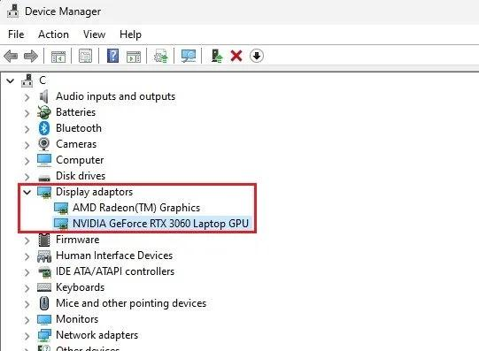
techy.how
Record your observation
Write your findings in this format:
Particular | Observation
GPU Brand | Intel / NVIDIA / AMD
GPU Model Number | Exact model shown in Device Manager
GPU Type | Integrated / Dedicated
How to identify the type:
- Integrated GPU: Built into the processor or chipset, such as Intel UHD Graphics or AMD Radeon Graphics.
- Dedicated GPU: A separate graphics processor, such as NVIDIA GeForce RTX or AMD Radeon RX.
Alternative method: Press Ctrl + Shift + Esc → open Task Manager → select Performance → click GPU to see its model.
Q2. Take a clear photo or screenshot of the cooling system (fan, heatsink, or liquid cooling setup) inside your PC or from a PC hardware simulator. Label the main cooling components and briefly describe their function.
Ans.
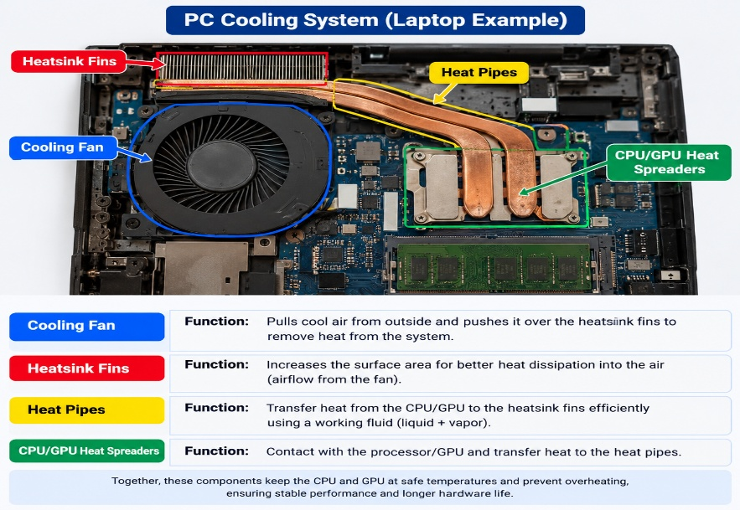
Practical: Identify and Label the PC Cooling System
The image above shows a laptop cooling system with its main components labelled. You can use it as a reference image for your practical assignment.
Components and their functions
No. | Component | Function
1 | Cooling Fan | Moves air through the cooling system to remove heat.
2 | Heatsink Fins | Disperse heat into the surrounding air.
3 | Heat Pipes | Transfer heat from the CPU/GPU to the heatsink fins.
4 | CPU/GPU Heat Spreaders | Collect heat from the processor and transfer it to the heat pipes.
Observation
The cooling system maintains a safe operating temperature for the CPU and GPU. It helps prevent overheating, improves system stability, and supports reliable computer performance.
Q3. Create a comparison table listing at least 3 differences between air cooling and liquid cooling systems for GPUs, including factors like cost, efficiency, and maintenance.
Ans.
Comparison Factor | Air Cooling (GPU) | Liquid Cooling (GPU)
Cost | Generally more affordable and cost-effective, utilizing simpler manufacturing and materials (heatsinks, copper pipes, and fans). | Higher upfront cost due to complex components like pumps, tubing, radiators, and coolant blocks.
Thermal Efficiency | Adequate for standard gaming and stock workloads, but prone to thermal throttling during prolonged, heavy loads as ambient case temperatures rise. | Superior heat dissipation; moves heat away from the GPU die much faster, maintaining lower temperatures and sustaining higher boost clocks under heavy stress.
Maintenance | Practically maintenance-free aside from occasionally dusting out the heatsink fins and fans. | Requires periodic monitoring (checking for pump noise or fluid degradation in AIOs; flushing and refilling custom loops).

Q4. Imagine you are building a gaming PC for streaming IPL matches and playing graphics-heavy games. Choose between air cooling and liquid cooling for your GPU, and justify your choice in 3-4 sentences based on your research.
Ans.
For a gaming and streaming PC handling heavy graphics and live IPL broadcasts, an air cooling solution is the ideal choice due to its high cost-effectiveness and reliable performance. It delivers adequate thermal efficiency for standard gaming and multitasking workloads without the steep upfront costs or complexity of liquid systems. Additionally, air coolers are virtually maintenance-free and eliminate any risk of fluid leaks or pump failures, making them a durable and practical option for long-term use.

